

**LEVEL DESIGN DOCUMENT**

**Current Owner:** Stefano D’Ambra

The **purpose** … **TODO**

|  |  |  |
| --- | --- | --- |
| Creation date: 19/10/20 14:49 | **REVISION HISTORY** | Last Modification: 27/10/20 19:41 |
| **WHO** | **WHEN** | **WHAT** |
| Niccolò Cappellini | 19/10/2020 14:49 | Document created |
| Niccolò Cappellini  Edoardo Carrer  Stefano D’Ambra | 23/10/2020 17:09 | First draft of the goal outline |
| Niccolò Cappellini  Edoardo Carrer  Stefano D’Ambra | 26/10/2020 17:00 | Updated goal outline |
| Stefano D’Ambra | 26/10/2020 19:10 | Added World Map |
| Niccolò Cappellini | 27/10/2020 19:05 | Added TOC, page numbers and Settings |
| Stefano D’Ambra | 27/10/2020 19:41 | Added World Diagram |
| Edoardo Carrer | 28/10/2020 20:00 | Added Themes |

**HIGH CONCEPT** **2**

**WORLD MAP** **3**

**SETTINGS** **4**

DIAGON ALLEY 4

KING’S CROSS STATION 4

HOGWARTS 4

Great Hall 4

Transfiguration Class 4

Potion Class 4

Spell Class 4

Exercise Room 4

Dumbledore Office 4

Library 4

Dormitory 4

FORBIDDEN FOREST 4

TOURNAMENT CAMP 4

TRIWIZARD ARENA 4

NOTT’S HIDEOUT 4

**SYNOPSIS** **5**

**STORY** **5**

**STORY FLOWCHART** **5**

**THEMES** **5**

**CHARACTERS** **5**

**WORLD DIAGRAM** **5**

**GOAL OUTLINE** **5**

# 

# HIGH CONCEPT

# WORLD MAP

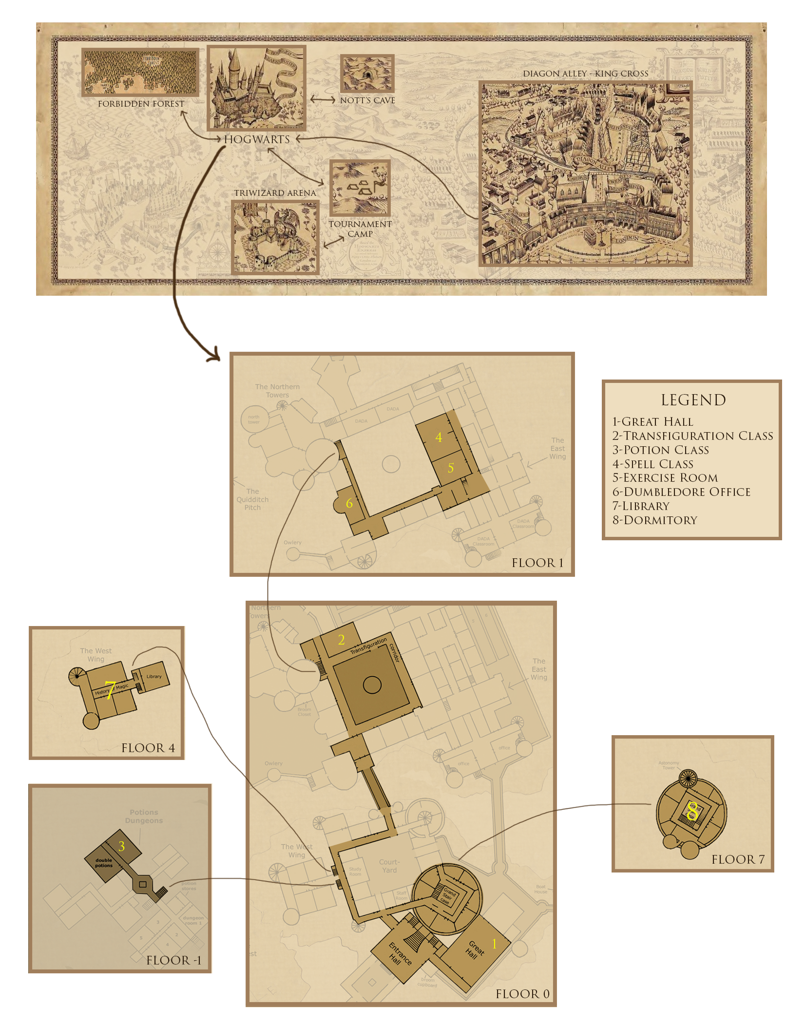

# SETTINGS

## DIAGON ALLEY

Diagon Alley is a secret alley located in London behind a pub called the Leaky Cauldron. The alley is a shopping area for wizards that contains shops, restaurants and other places of interest. There it's possible to buy all the items required for Hogwarts, from the uniform from the Madam Malkin's Robes for All Occasions to the first wand from Ollivander's.

## KING’S CROSS STATION

King's Cross Station is one of the main train stations in London, it's used by wizard students to take the Hogwarts Express that takes them to the homonymous school. The train can be reached by crossing Platform 9¾, a secret Platform hidden in a wall between platforms 9 and 10.

## HOGWARTS CASTLE

### Great Hall

The Great Hall is the main gathering area in the school. It's the room for special events, such as the Sorting ceremony and for announcements. It's also used as a canteen and as a place of aggregation.

### Transfiguration Class

Transfiguration Class is the room where the transfiguration subject is taught. Here it is possible to learn how to change the appearance of an object or a person.

### Potion Class

Potion Class is the room where wizards learn how to correctly brew potions. The classroom provides students with all the ingredients needed to create the potions.

### Spell Class

Spell Class is the room where students learn how to defend themselves against all types of danger from harmful creatures to duelling other wizards.

### Exercise Room

In the exercise room students are free to practice the magical arts without the risk of hurting anyone.

### Dumbledore Office

It's the personal room of the professor Albus Dumbledore, where he spends part of his time when he is not lecturing.

### Library

The library contains tens of hundreds of books dealing with the magical arts. Here students can study or borrow books when necessary. Inside the library there is a forbidden section that contains books that are rare and/or considered inappropriate for younger students (dealing with the dark arts).

### Dormitory

The dormitory is the area where magicians rest during the night.

## FORBIDDEN FOREST

The Forbidden Forest, also known as the Dark Forest is located near the Hogwarts School. Trespassing the area is prohibited for students because the forest contains various dangerous creatures. The forest is full of trees and is difficult to cross, especially at night. The heart of the forest is home to many spiders, including large ones, even Acromantulas, a giant magical species of spider.

## TOURNAMENT CAMP

The tournament camp is an agglomeration of tents located outside of Hogwarts, where Triwizard Tournament participants can rest and socialize before participating in the trials.

## TRIWIZARD ARENA

In the arena the challengers participate in the three trials of the tournament, thanks to magic it is possible to change the shape of the arena to accommodate the different challenges.

## NOTT’S HIDEOUT

Outside the borders of Hogwarts, hidden in the mountains, is the cave used as a hideout by Nott the Death Eater. The cave is protected by magical creatures. The hiding place contains Nott's personal belongings that show his real identity.

# 

# SYNOPSIS

# STORY

# STORY FLOWCHART

# THEMES

**Honour**: The desire to stand out for our commitment, which in a world where nothing is as it seems can lead to madness...

Minerva is a young educated woman with a strong sense of honor, for her being the best student is the most important thing during her studies at Hogwarts, and for her purpose she would do anything.

**Trust**:The main theme of the story concerns the importance of the choices that are made and their impact on the relationships of trust between people.

In the game Minerva takes choices that influence herself and her relationships, sometimes in a good way, sometimes in others...

**The difficulty of distinguishing good from evil**:Everything always depends on the point of view and also on the knowledge/absence of information.

Through the game Minerva has to decide which way to choose based mainly on the information received from her Transfiguration professor, Dumbledore, and her new "friend" Nott.

# CHARACTERS

# WORLD DIAGRAM

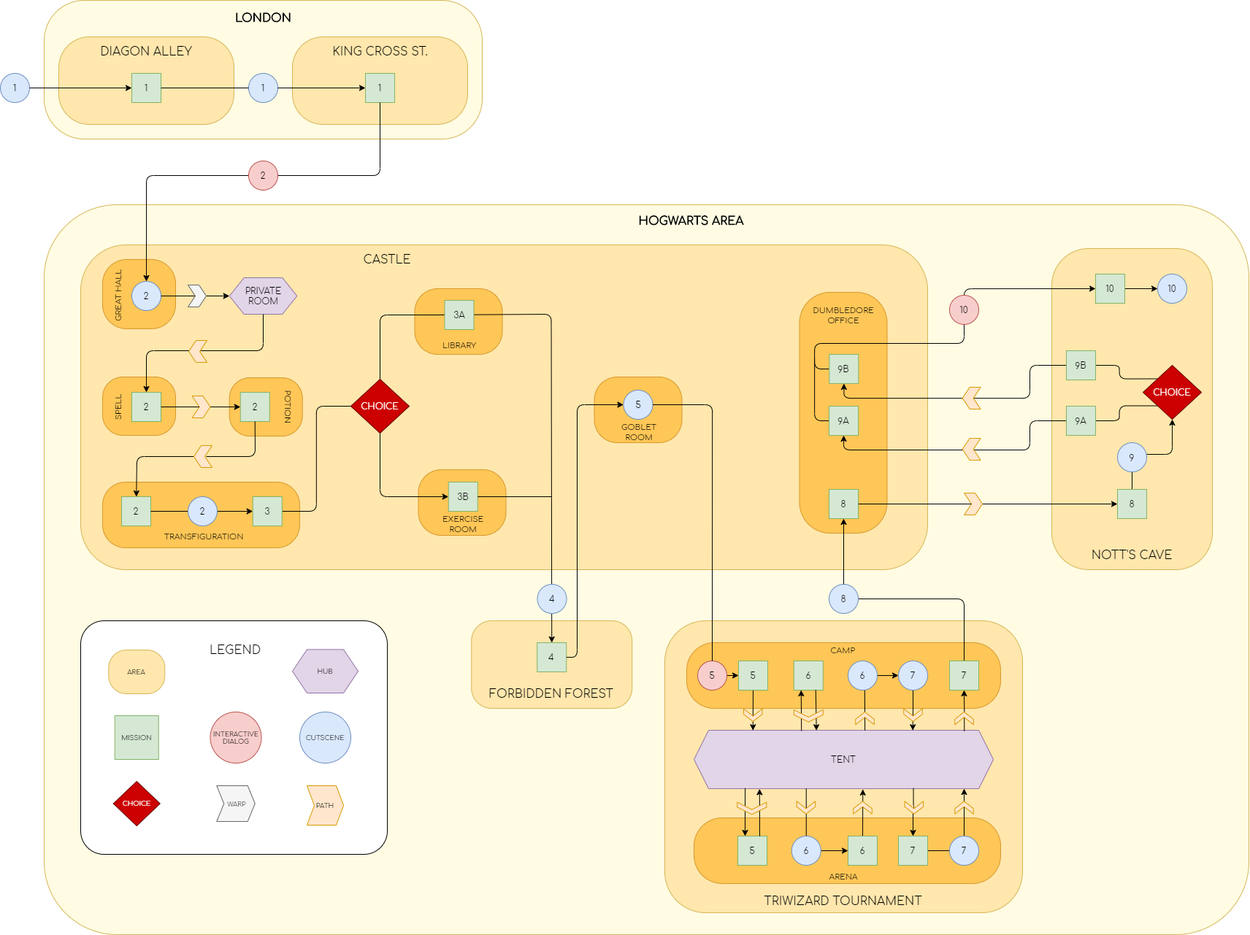

# GOAL OUTLINE

1. **WELCOME TO DIAGON ALLEY!**
   1. **Enter to Diagon Alley**
   2. **Finish School purchases**
      1. **Go to Pottidge’s Cauldron Shop**
      2. **Go to Quality Quidditch Supplies**
      3. **Go to Flourish & Blott’s**
      4. **Go to Madam Malkin’s Robes for All Occasions**
      5. **Go to Magical Menagerie**
      6. **Go to Ollivander’s**
   3. **Find what is going on at Gambol & Jape: Wizarding Joke Shop**
   4. **Take the train to Hogwarts**
2. **FIRST DAY OF SCHOOL** 
   1. **Go to your Common room**
   2. **Explore your room and go to sleep**
   3. **Go to lessons**
      1. **Follow spell lesson**
      2. **Follow potions lesson**
      3. **Follow transfiguration lesson**
   4. **Talk with Dumbledore in his office**
3. **CHOOSE YOUR WAY, MINERVA**
   1. **Follow transfiguration lesson**
   2. **Choose your way:**

**a) Sneak into the library at night**

**b) Go to duel room and learn new spells**

1. **INTO THE FOREST**
   1. **Go with Nott to the Forbidden Forest**
   2. **Reach the Aracnomantula’s den**
      1. **Defeat all the spiders**
      2. **Take some spider webs**
      3. **Overcome the Acromantula**
         1. **kill or spare it**
      4. **Take Aracnomantula’s eggs**
      5. **Go back to Nott**
   3. **Craft the potion recipe and try it**
2. **TRIWIZARD TOURNAMENT: KILL THAT BEAST**
   1. **Insert your name into the Goblet of Fire**
   2. **Explore the tournament area**
      1. **Speak with other challengers**
      2. **Speak with Nott**
   3. **Reach the entrance of the arena to start the first trial**
   4. **Retrieve the item protected by the beast**
3. **TRIWIZARD TOURNAMENT: CHIMERA’S DUNGEON**
   1. **Discover the clues about the retrieved item**
   2. **Leave the camp to start the second trial**
   3. **Find a way out from the Chimera’s dungeon**
      1. **Exceeds the first room**
      2. **Exceeds the second room**
      3. **Exceeds the third room**
4. **TRIWIZARD TOURNAMENT: FREE FOR ALL**
   1. **Reach the entrance of the arena to start the last trial**
   2. **Defeat the other challengers**
      1. **Reach the Triwizard Cup or retrieve it from the other wizard**
      2. **Win the Tournament!**
   3. **Celebrate your victory**
5. **NOT EVERYTHING IS AS IT SEEMS**
   1. **Tail Nott to find where he lives**
   2. **Explore the cave**
      1. **Defeat all the enemies**
   3. **Reach the hideout**
      1. **Inspect the room**
      2. **Read the Diary**
6. **THE DARK LADY AWAKENS**
   1. **Use the Felix Felicis potion**
   2. **Sneak in Dumbledore office**
      1. **Put the port key on his desk**
   3. **Wait Dumbledore in the cave to fight him**
7. **AS IT HAS ALWAYS BEEN**
   1. **Come back to Dumbledore**
      1. **Give the proof of Nott guiltiness to him**
   2. **Use the Felix Felicis potion**
   3. **Search the Nott secret room**
      1. **Defeat all the enemies**
8. **TIME END**
   1. **Defeat Dumbledore or Nott**